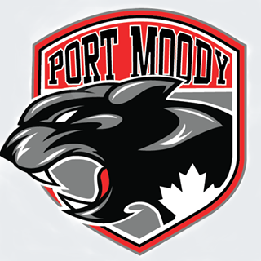

Port Moody Amateur Hockey Association
COACHING APPLICATION

Please complete the following:

Name: _____________________________________________________________________
(Given Name) (Middle Name) (Surname)

Address:___________________________________________________________________
City:__________________________________ Prov:______ Postal Code:_______________
Home Phone:___________________________ Mobile:____________________________
Email:_____________________________________________
Birth Date (YY/MM/DD): 19_____/______/______

Please circle one of the following:
Are you interested in a Head Coach position: Yes No
Are you interested in an Assistant Coach position: Yes No
What age group are you applying for (circle one or more)?:

- Initiation H1, H2, H3 or H4
- U11A or U11C (formerly Atom)
- U13A or U13C (formerly PeeWee)
- U15A or U15C (formerly Bantam)
- U18A or U18C (formerly Midget)
- A = Rep C = House
Do you anticipate having a child on the team you are applying to coach? Yes No
Qualifications
Have you completed the National Coaching Certification Program (NCCP)? Yes No
If yes, please indicate your NCCP#____________________
Have you completed your criminal record check (and is up to date)?. Yes No
Do you have any experience in Coaching? Yes No
If yes, please indicate:

Year Association Team/Division Position

______________________________________________________________________________

______________________________________________________________________________

______________________________________________________________________________

______________________________________________________________________________

______________________________________________________________________________

Please circle the following Hockey Canada certifications:
Respect in Sport Not completed In progress Completed/certified
Intro to Coaching (Coach 1) Not completed In progress Completed/certified Intro to Coaching (Coach 1) Not completed In progress Completed/certified
Development 1 Not completed In progress Completed/certified
Planning a Safe Return (COVID 19) Not completed In progress Completed/certified

Have you completed the NCCP “Make Ethical Decisions” Online Evaluation? Yes No

Have you completed concussion training (CATTonline.com) Yes No

Additional Coaching Experience Outside of Amateur Hockey

Year Sport Association Team/Division Position

_____________________________________________________________________________
_____________________________________________________________________________
_____________________________________________________________________________

Acknowledgement

- I hereby consent to the disclosure of the above information.
- I hereby acknowledge the authority of the Port Moody Amateur Hockey Association, the British Columbia Hockey Association, Hockey Canada and Coaching Association of Canada, and I agree to carry out and abide by their constitutions, bylaws, rules, regulations and policies.
- I hereby acknowledge that I have read and understand the coach’s role outlined in the “Coaches’ Code of Conduct” attached to and forming part of this Coaching Application Form.
- I hereby agree to familiarize myself with the National Coaching Certification Program (NCCP) requirements for coaching amateur Hockey and ensure that I maintain the required level of certification.
- I hereby agree to and will abide by the Port Moody Amateur Hockey Fair Play Guidelines.
- Upon request, I agree to obtain and submit a Police Background Check Consent Form/Criminal Record Check (CRC), which is a requirement for coaching.

Signature: _____________________________ Date: _____________________

Please email your completed application to coachcoordinator@pmaha.com

